HW4 Figures Submission

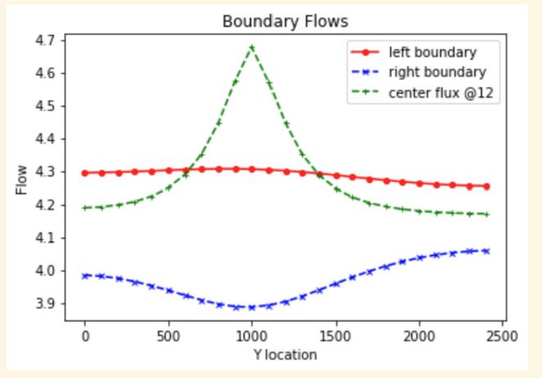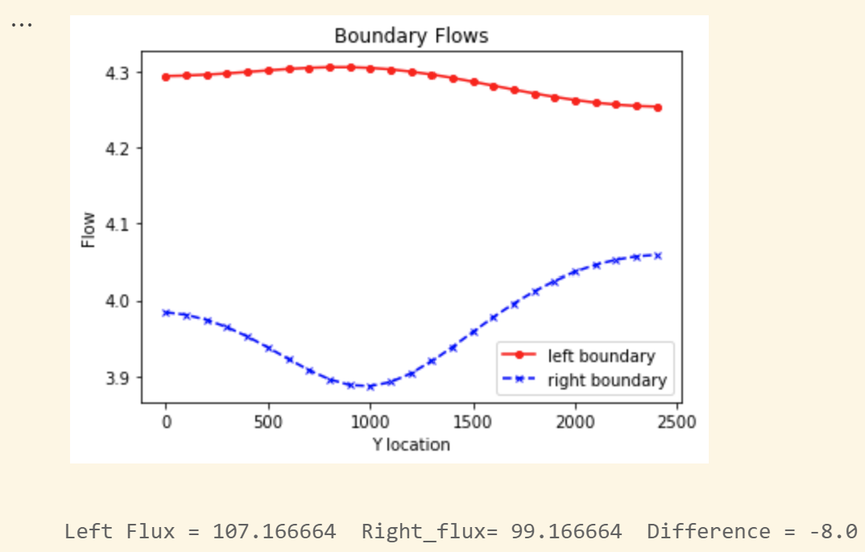

Base case boundary flows plots

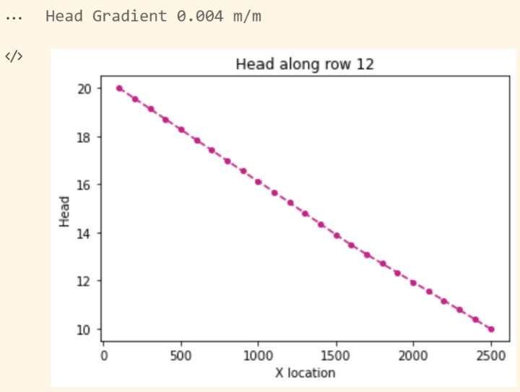

Base case head gradient plots along row 12

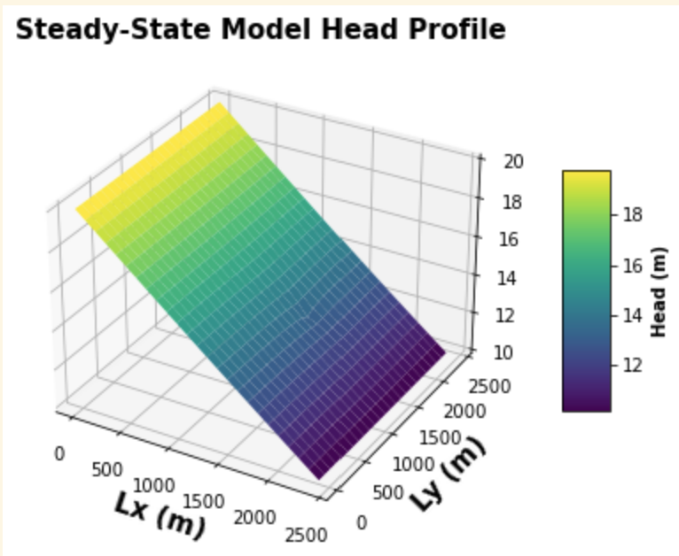

Base case head profile plot

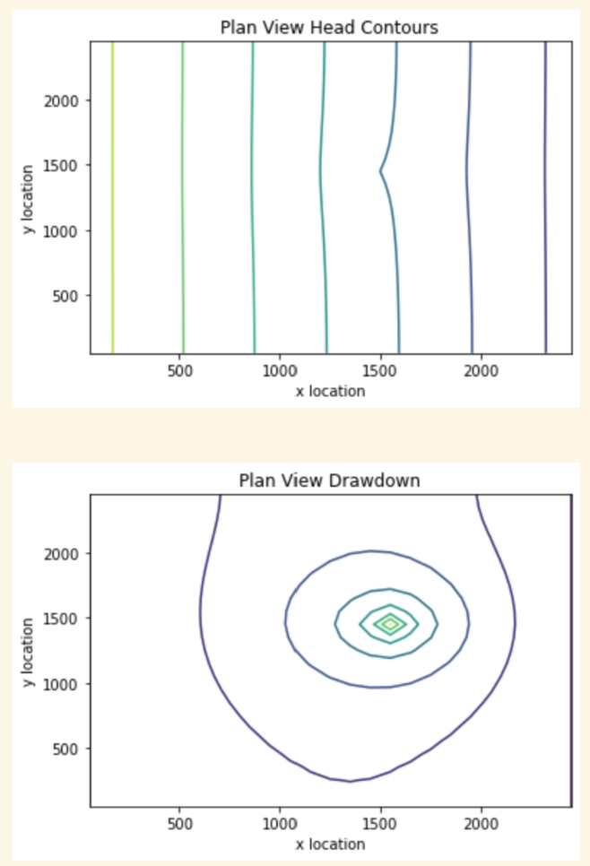

Base case head contours and plan view drawdown plots

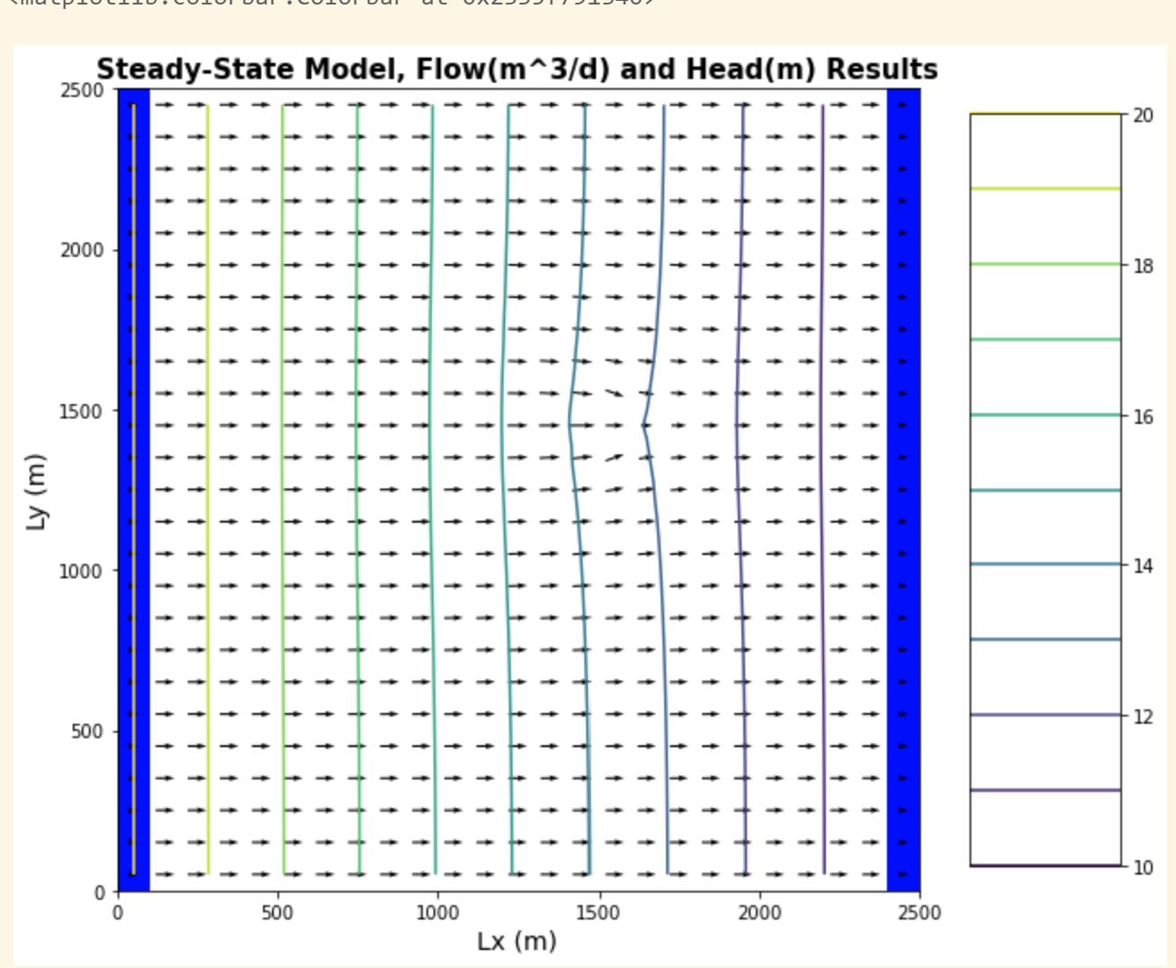

Base case flow map and head profile plot

First move case figures

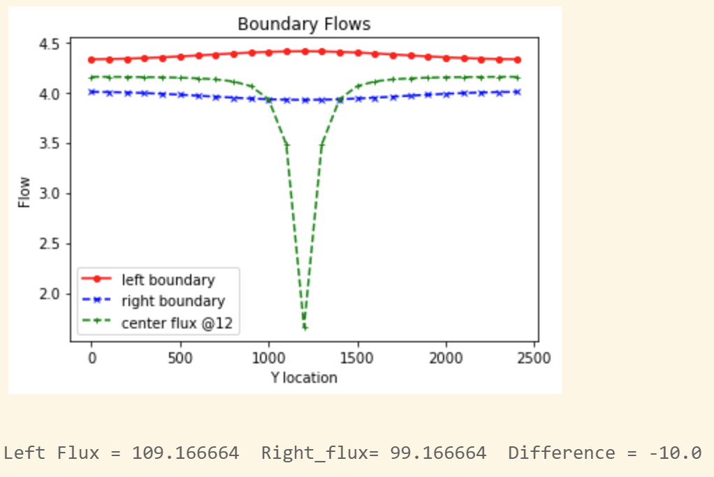

Boundary flows after well moved to [0,12,12] and flux changed to -10

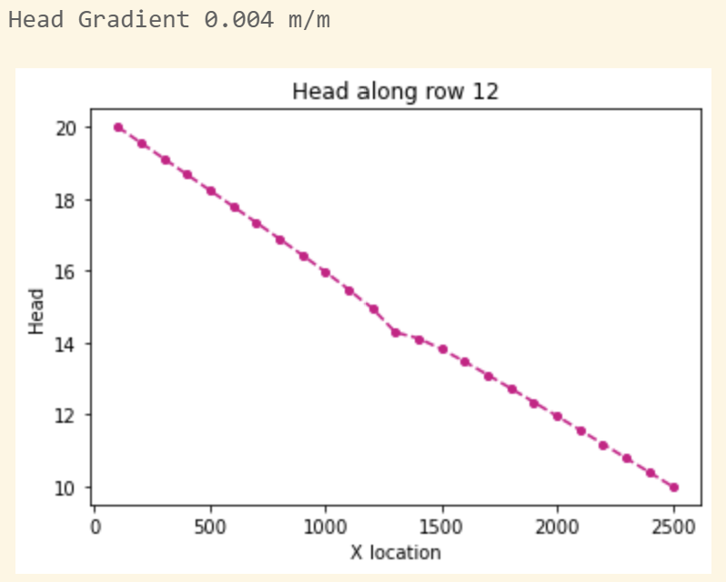

Head profile after well moved to [0,12,12] and flux changed to -10

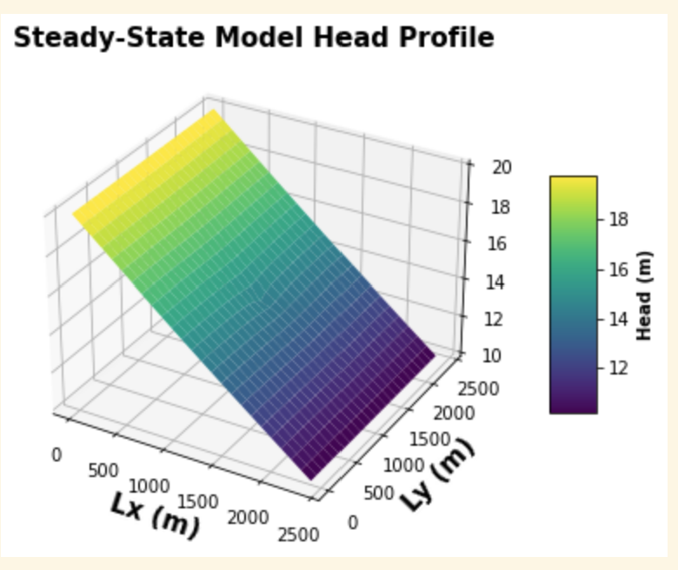

3d head profile after well moved to [0,12,12] and flux changed to -10

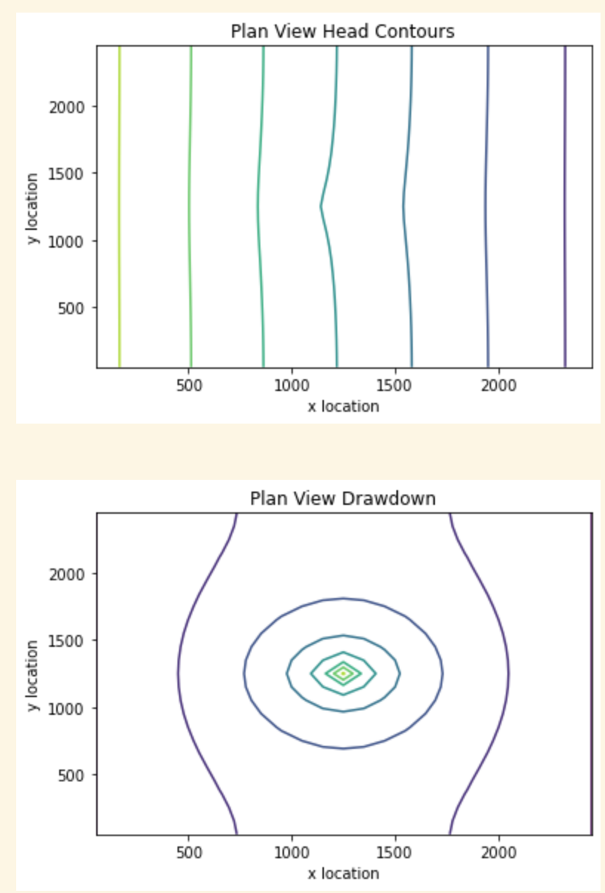

Drawdown plot and head contours after well moved to [0,12,12] and flux changed to -10

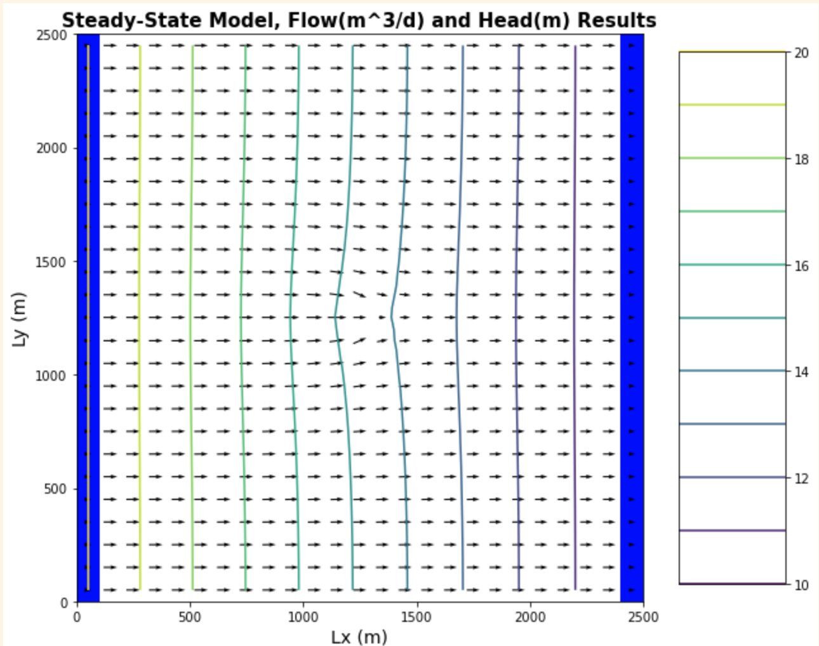

Flow map and head contours after well moved to [0,12,12] and flux changed to -10

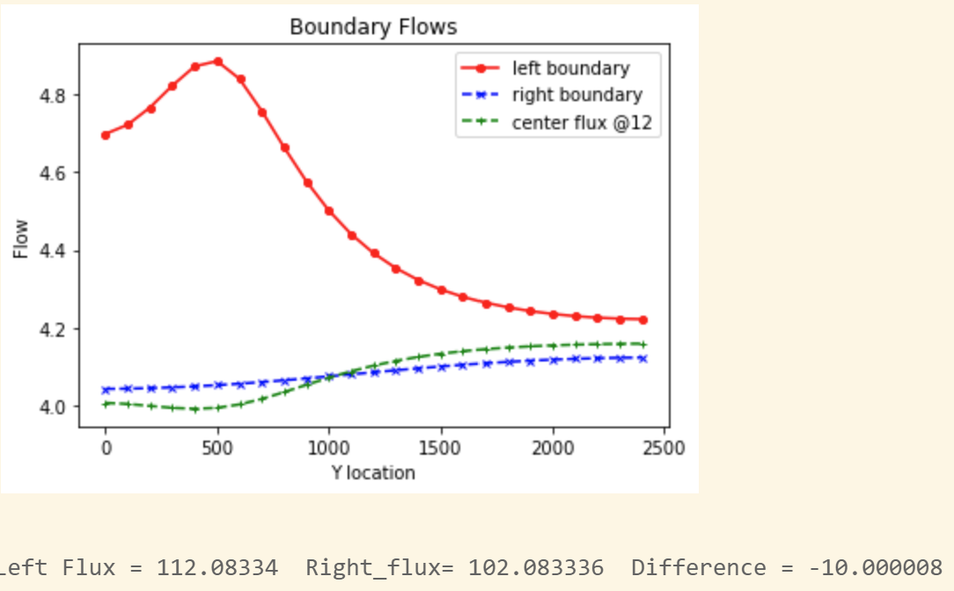

Boundary flows @ [0,5,5] -10 flux

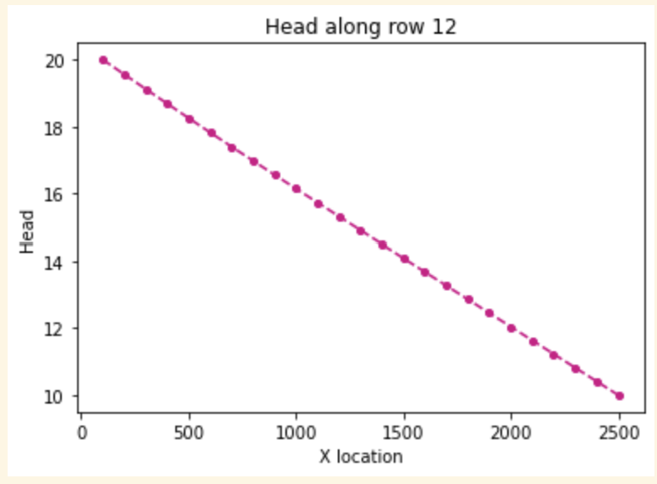

Head profile of [0,5,5] -10 flux

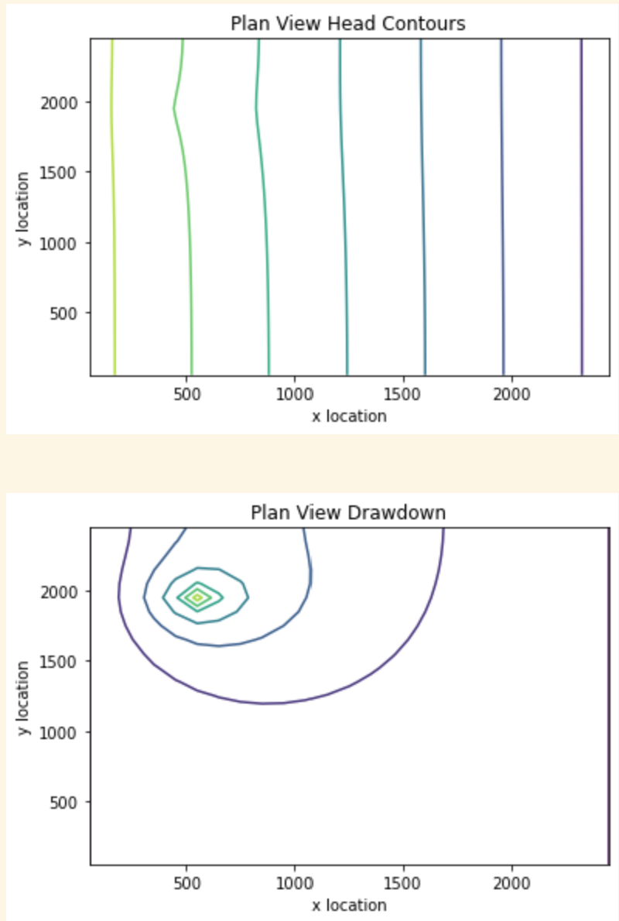

Drawdown and head contour plot @ [0,5,5] -10 flux

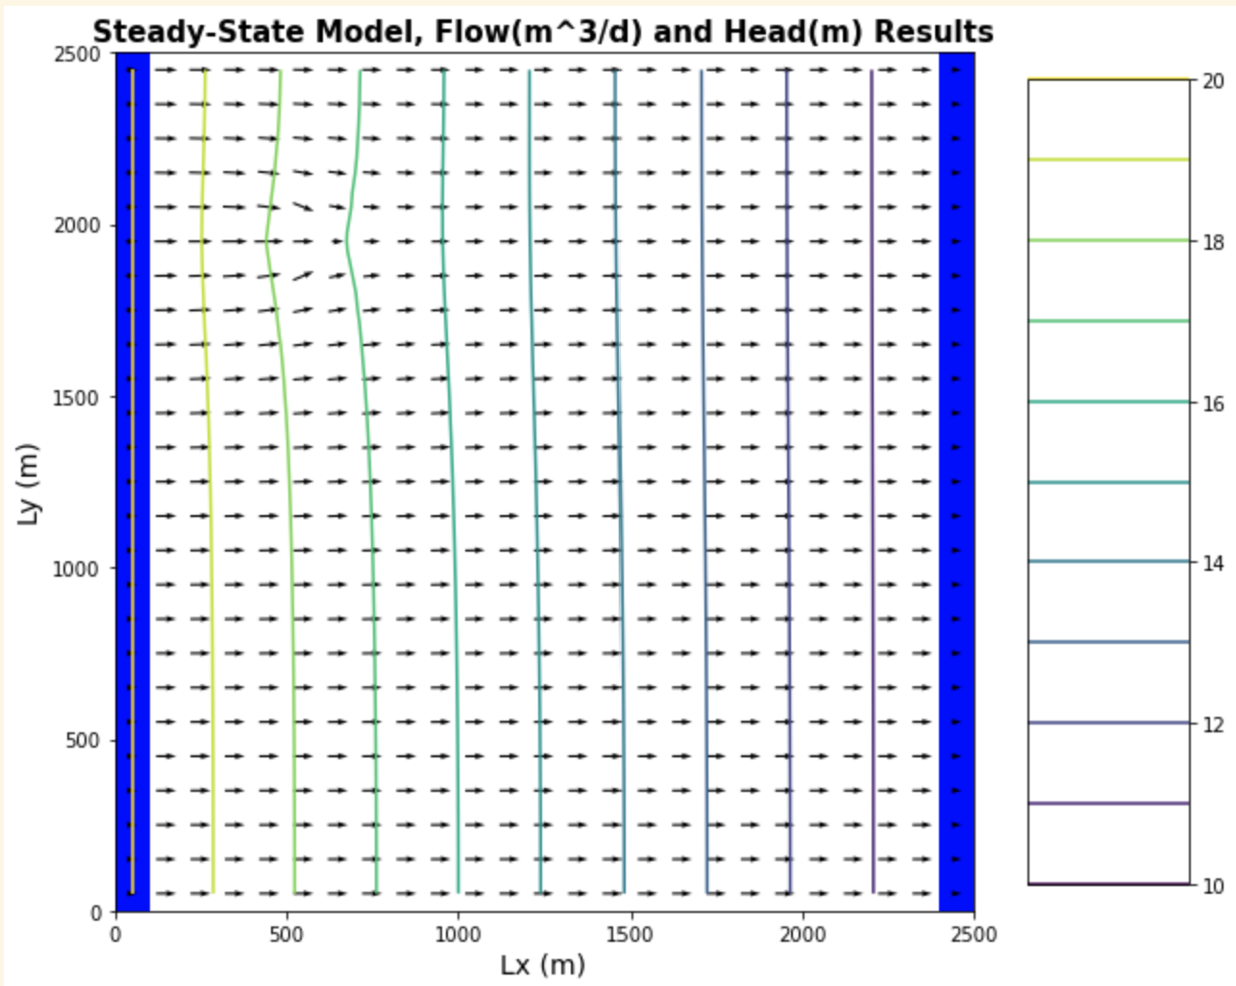

Flow map and head contours @ [0,5,5] -10 flux